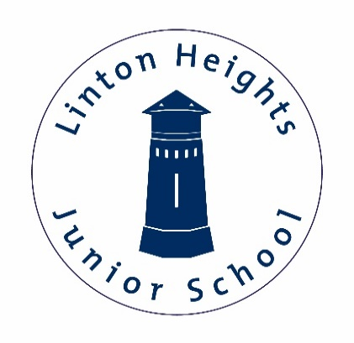

**Maths:** In this half term we will be focusing on how to multiply and divide by 6, 7, 9, 11 and 12. They will begin to understand mathematical vocabulary such as 'quotient' in relation to division. They will learn how to calculate multiplication equations using the multiplication facts that they know. They will understand the difference between sharing and grouping and they will understand the commutative law in multiplication.

**English:** In English we will be looking at a poem called the ‘the Sound Collector’ where the world’s sounds are taken. This will lead into us creating our own version of the poem called ‘The Colour collector’. In whole class reading we will start by looking at a book called ‘The Wild Robot’ a wonderful story that has recently been made into a film (family film recommendation for all!).

Resilience

Ambition

Respect

**Year 4 Curriculum Newsletter**

**Autumn Term 2**

**History**

How children’s lives have changed

https://www.kapowprimary.com/subjects/history/lower-key-stage-2/history-year-3-4/how-have-childrens-lives-changed/

**Class 3:** Mrs Aslan and Mrs Taylor

**Class 4:** Mr Gracie

Honesty

Kindness

Responsibility

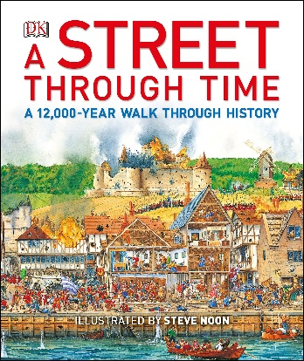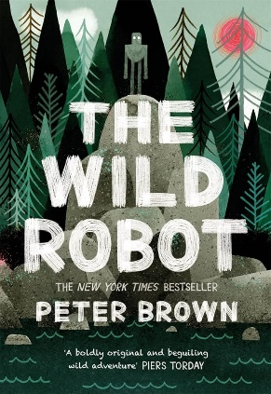

**PE:**

This term we will be doing both Dance and Hockey. We will work on coordination, sequencing, rhythm and team work.

**Enrichment:**

Pantomine

Christmas play

**PSHE:**

Families and relationships

https://www.kapowprimary.com/subjects/rse-pshe/lower-key-stage-2/year-4/families-and-relationships/

**Music:**

In Year 4, children learn to play the ukulele and this half term we will start by learning about open strings and the chord C major. We will also continue to practise our Year 4 performance and songs!

**DT:**

Electrical systems: Torches

https://www.kapowprimary.com/subjects/design-technology/lower-key-stage-2/year-4/electrical-systems-torches/

**French:**

Clothes

https://www.kapowprimary.com/subjects/french/lower-key-stage-2/year-4/clothes-getting-dressed-in-france/

**Science:**

Electricity

https://www.kapowprimary.com/subjects/science/science-lower-key-stage-2/year-4/electricity-and-circuits/

**RE:**

Are all religions equal?

https://www.kapowprimary.com/subjects/religion-and-worldviews/religion-and-worldviews-lower-key-stage-2/year-4/are-all-religions-equal/

**Reminders:**

PE days: Reading record check every Friday

New Mathletics tasks set every Monday